 |  |  | 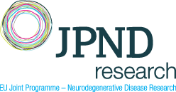
QualBulMND
Quality of life correlates of bulbar and pseudobulbar dysfunction in late stage MND: clinical determinants, screening tools, opportunities for evidence-based QoL-focused interventions
Bulbar dysfunction (BD) presents as dysphagia and dysarthria, which may lead to weight loss, im-paired communication, orofacial pain and aspiration pneumonia. Bulbar dysfunction in MND is a negative prognostic indicator of survival, requires careful monitoring and necessitates well-timed multidisciplinary interventions; referral to speech-language pathology (SLP), feeding tube placement, augmentative communication devices etc. Pseudobulbar affect (PBA) manifests in disproportionate emotional responses to minimal or non-contextual stimulus. BD and PBA develop in a range of neurological conditions, but are pathognomonic of motor neuron diseases (MNDs) with considerable diagnostic, management and quality of life (QoL) implications.
The applicants of this consortium propose a robust, multi-site, multimodal, study to evaluate biological underpinnings and QoL impact of BD and PBA in MND. A purpose-designed neuroimaging protocol will be implemented to evaluate the cortical, white matter, brainstem, cerebellar and muscle components of bulbar function. The presence and severity of bulbar dysfunction will be evaluated using a validated algorithm based on acoustic and kinematic features. A comprehensive battery of tests will be administered to map the incidence, clinical associations, longitudinal evolution and social sequelae of bulbar and pseudobulbar impairment. A transnational comparison approach will be utilised to document cultural and healthcare system differences in management of BD and PBA. The work will lead to an improved understanding of the aetiology and impact BD & PBA and the establishment and cross-validation of best practice recommendations. Ultimately, the project seeks to raise public awareness of the clinical, social and QoL impact of BD & PBA.
Total Funding : | 1.53 M€ | 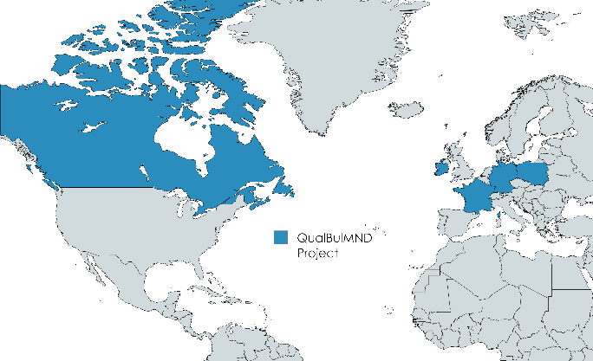
Duration : | 3 years
Coordinator : | Prof. Peter Bede  : bedep@tcd.ie  
Consortium Members

 | Prof. Peter Bede | Trinity College Dublin, Ireland
 | Prof. Dorothée Lulé | University of Ulm, Germany
 | Prof. Magdalena Kuźma-Kozakiewicz | University of Warsaw, Poland
 | Prof. Yana Yunusova | University of Toronto, Canada
 | Prof. Aude-Marie Grapperon | Aix-Marseille University, France

