 |  |  | 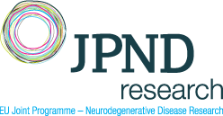
ReablDEMiP
ReableDem in Practice: Reablement in Dementia Care Across Europe
Dementia affects over 55 million people globally. It leads to progressive cognitive and functional decline and consequently severely impacts individuals’ engagement in meaningful daily and social activities and increases the demand for care partners' support, community services, and professional intermediate and long-term care. Reablement—a person-centred, resource-oriented, goal-directed approach—has demonstrated positive outcomes in people living with dementia and their care partners as well as economic benefits. However, the global adoption of reablement remains limited, particularly for those in moderate to severe stages of dementia.
The ReableDem-iP project aims to transform dementia care in Europe by accelerating the adoption of reablement through cross-national collaboration across six European countries—Czech Republic, Germany, Italy, Netherlands, Norway and Turkey—with additional expertise from Australia and the United Kingdom. This 36-months project focuses on:
(1) exploring interest holders' beliefs and attitudes regarding reablement in dementia care;
(2) identifying macro-level contextual factors that influence the adoption of reablement;
(3) developing and testing culturally adapted outcome measures;
(4) identifying and implementing best practices for capacity building;
(5) launching international awareness campaigns to reduce stigma of dementia and promote reablement.
Additionally, a training program for early-career researchers will be offered in collaboration with INTERDEM. A distinctive aspect of this project is the Limburg Living Lab approach, an ecosystem that has existed for 27 years and unites practice, education, and research. Within the Living Lab, scientific research is conducted in co-creation with interest-holders. The European Network of Living Labs (ENoLL) will support our project.
Total Funding : | 1.81 M€ | 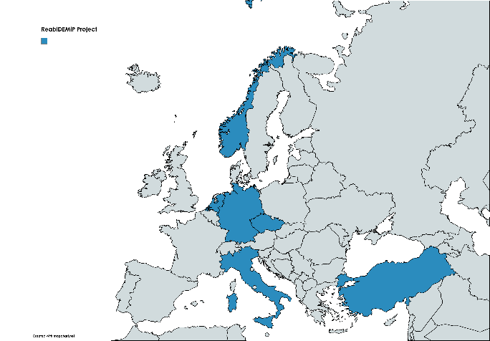
Duration : | 3 years
Coordinator : | Dr. Silke Metzelthin  : s.metzelthin@maastrichtuniversity.nl  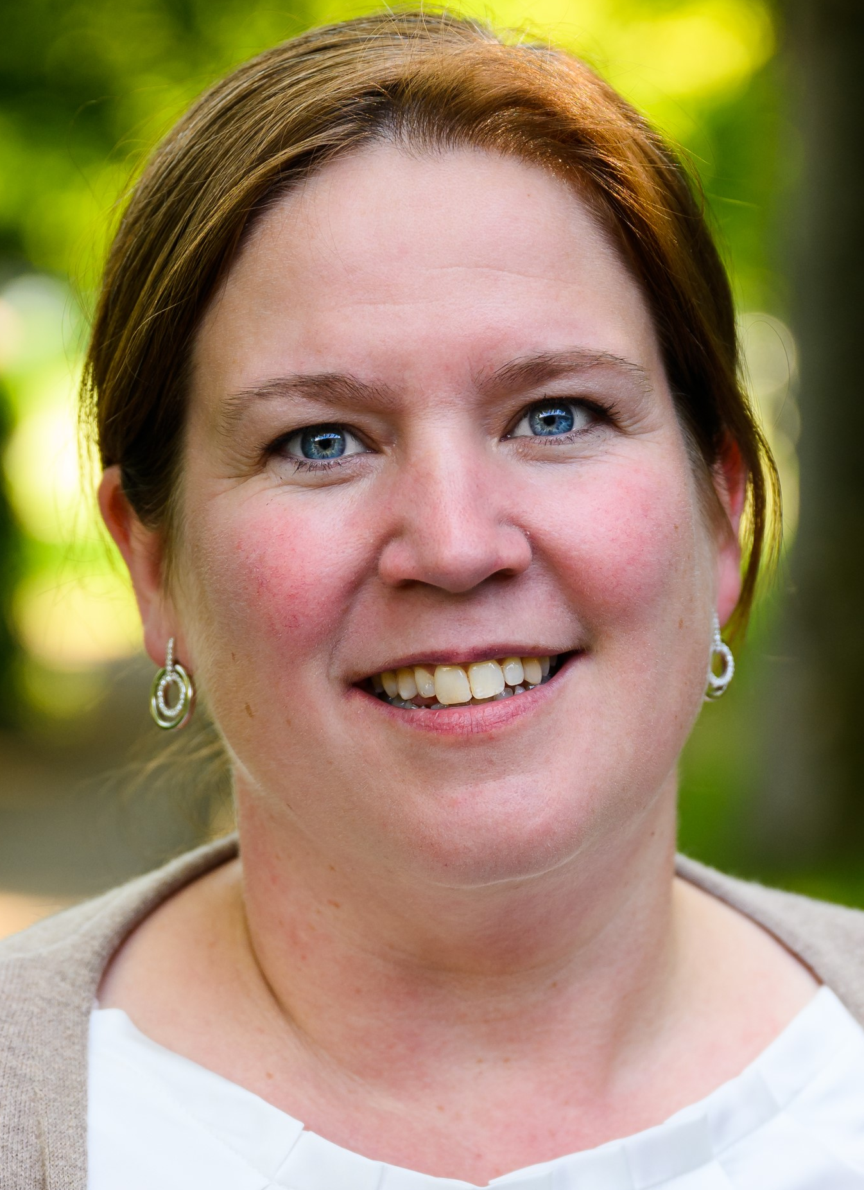
Consortium Members

 | Dr. Silke Metzelthin | Care and Public Health Research Institute, Maastricht University, The Netherlands
 | Prof. Hanne Tuntland | Western University of Applied Sciences, Norway
 | Dr. Vincenza Frisardi | IRCCS-AOUBO, Institute of Scientific Research, Italy,
 | Assoc. Prof. Iva Holmerová | CELLO FHS, Charles University Prague, Czech Republic
 | Dr. Anja Bieber | Martin Luther University Halle-Wittenberg, Germany
 | Dr. Martin N. Dichter | University of Cologne, Germany
 | Prof. Filiz Can | Hacettepe University, Turkey

